Diode Clipping Circuits

Basic Definition:
There is a variety of diode circuits called clippers (limiters) that have the ability to "clip" off a portion of the input signal above (positive) or below (negative) certain level without distorting the remaining part of the alternating waveform. Depending on the orientation of the diode, the positive or negative region of the input signal is "clipped" off.
There are two general categories of clippers: series and parallel. The series configuration is dined as one where the diode is in series with the load. While the parallel variety has the diode in a branch parallel to the load (see Fig. -1).

vi D
V
+
vi
−
+
R vo
−
T
vo

T/2 T

0 T/2 t 0 t
  - V − V
Simple Series Clipper
vi R vo
V
V
0 | T/2 T

0 T/2
− V
+
T vi
t
−
+
D vo
t
−

Simple Parallel Clipper

Fig. -1

Example -1:
Biased Series Clipper, see Fig. -2.

E D
5.2V
Si
R
vi
9
0
T/2
T
- 9
vi vo
t

vi vo
Vi
13.5
4.5
T/2
t1
t2
T
0
- 4.5
vo
13.5
4.5
0
E − VT
4.5V
Vi
D

Ideal
R

For t = 0 → t₁ and t₂ → T; D ON,
and v_{o} = v_{i} + 4.5 V. t
For t = t₁ → t₂; D OFF,
and v_{o} = 0 V.

vi t
vo
13.5
4.5
- 9
- 4.5
0
9

Fig. -2 (cont.)

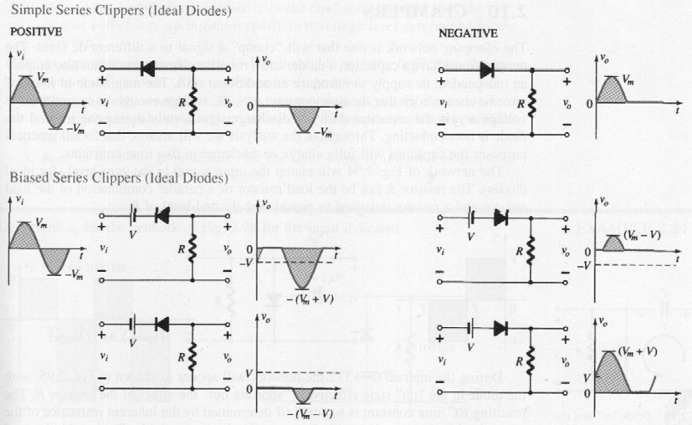
A variety of series and parallel clippers with the resulting output for the sinusoidal input are provided in Fig. -3.
Fig. 3

Example -2:

Double Diode Series Clipper, see Fig. -4.
3.3V
E2
Si
D2
Ge
R
7.7V
12
0  -12 | T/2 T

vi
E₁ D1
vi v_{o}
t

E + V V
D1
1 T1 i1
4V
E + V V
Ideal
D2
2 T₂ i2
R
8V
Ideal
Fig. -4

vi v_{o}

For t = 0 → t₁, t₂ → t₃, and t₄ → T; both D₁ and D₂ will be OFF,
vi
V
20
i2
8
T/2
T
t1 t2 t3 t4
- 4 0
- 16
vo
Vi
1
8
- 40
and v_{o} = 0 V.
For t = t₁ → t₂; D₁ ON while D₂ OFF,
and v_{o} = Vi = v_{i} – 4 V.
1
For t = t₃ → t₄; D₁ OFF while D₂ ON, t
and v_{o} = Vi = v_{i} + 8 V.
2

vi
vo
8
- 12 - 8
0
4
12
- 4
t

Fig. -4 (cont.)

Example -3:

Biased Parallel Clipper, see Fig. -5.

R
vi
10
0
T/2
T
- 10
v
i vo

- Si
- 5.7V

t

Fig. -5

 R
v
o vi
- id = 0

Vtransition
- E
10
5V

Vtransition – id R – Vd + E = 0;
V_{transition} = 0.7 – 5.7 = – 5 V.
For t = 0 → t₁ and t₂ → T; D ON, and v_{o} = – 5 V.
For t = t₁ → t₂; D OFF, and v_{o} = v_{i}.
vo
- 10 - 5
10
0
- 5
- 10

vi

0

-5

- 10

vo

0

-5

T/2

t1 t2
T

t
Vtransition

t

- 10

Fig. -5 (cont.)

A variety of parallel clippers with the resulting output for the sinusoidal input are provided in Fig. -6.

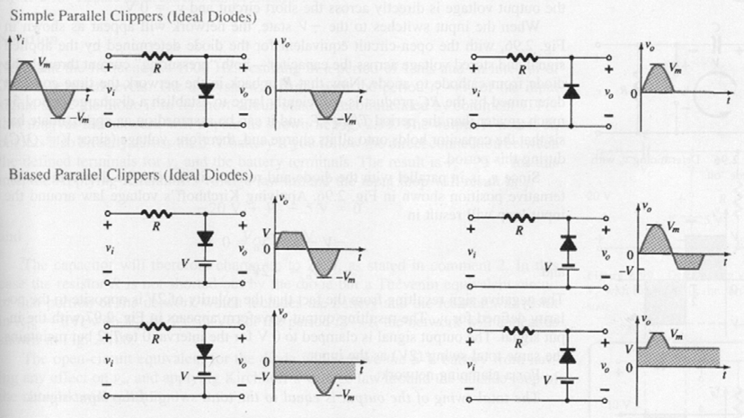

Fig. -6

Example -4:

Double Diode Parallel Clipper, see Fig. -7.
vi
9
T
0
T/2
- 9

R
vi vo
D1
E1
Si
D2
2.3V E₂
Si
5.3V

t

R R
v
 o vo
d

+
Vtr
1
−
i 1 = 0D1
E1
d
Si
2.3V
+
Vtr
2
−
i 2 = 0D2
E2
Si
5.3V

Vtr – id
R – V_{d} – E₁ = 0;
Vtr
+ id
R + V_{d} + E₂ = 0;

1 1 2 2
2

Vtr = 0.7 + 2.3 = 3 V.
1
Vtr
= – 0.7 – 5.3 = – 6 V.

Fig. -7

For t = 0 → t₁, t₂ → t₃, and t₄ → T; both D₁ and D₂ will be OFF,
vi
9
3
t
1
t t
2 3
t T
4
Vtr1
0
T/2
- 6
- 9
Vtr
2
vo
3

0

- 6
and v_{o} = v_{i}.
For t = t₁ → t₂; D₁ ON while D₂ OFF,
and v_{o} = 3 V. t
For t = t₃ → t₄; D₁ OFF while D₂ ON,
and v_{o} = – 6 V.

vi t
vo
- 9 - 6
3
0 3
- 6
9

Fig. -7 (cont.)

