**Al- Mamoun University** **College** 

**Medical Instrumentation Engineering**

**Techniques Department**

**LAB. 2**

Estimation of Serum Calcium

**For**

Students of Second Stage

Medical Instrumentation Department

**By**

**Ass.lec. Shahad Monther**

**Medical Instrumentation Engineering Techniques Department**

**2024**

**Objectives الأهداف**

1. **• Definition of calcium.**
2. **• Clinical significant.**
3. **• Functions of calcium.**
4. **• Procedure.**
5. **• Calculation.**
6. **• Reference values.**

**Definition of calcium**

• Calcium is a mineral that is essential to bone health, cardiovascular health, muscle maintenance, circulatory health, and blood clotting.

• While calcium is found in milk and dairy products, it is also available from other food sources, such as green leafy vegetables, seafood (eating salmon with the bones provides an even greater dose), almonds, blackstrap molasses, broccoli, enriched soy and rice milk products, figs, soybeans and tofu..

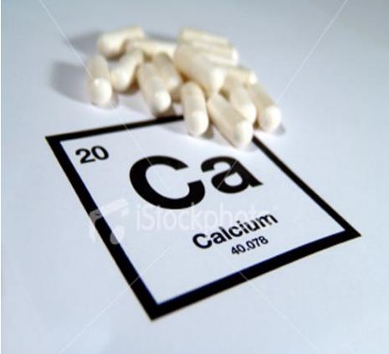

**Body requirements for Calcium:**

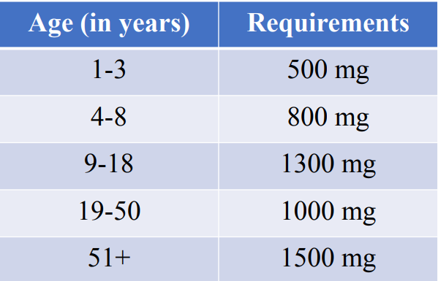

• Pregnant and lactating women are recommended a daily calcium intake of 1000mg.

**Functions of calcium**

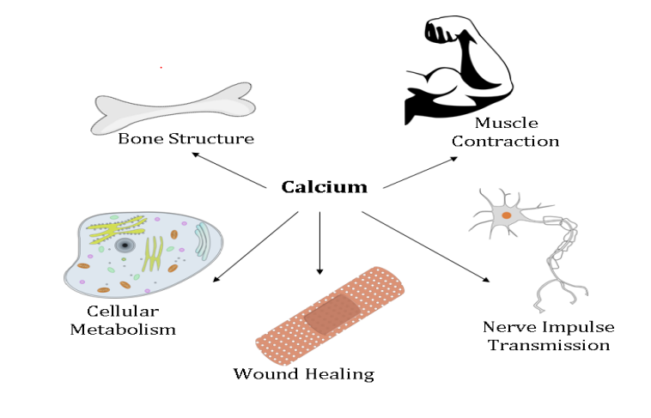.

**Forms of Calcium in the body:**

45% in ionized form (the physiologically active form).

45% bound to proteins (predominantly albumin).

10% complexed with anions (citrate, sulfate, phosphate).

**Clinical significant**

***•Hypercalcemia (high)***

•Hyperparathyroidism

•Metastatic bone tumor

•Multiple myeloma

• Use of certain medications such as lithium, tamoxifen, and

thiazides

•Sarcoidosis

***•Hypocalcemia (low)***

•Hypoparathyroidism

•Magnesium deficiency and hypo proteinemia

•Malabsorption due to gastro intestinal

•Hyperphosphatemia

•Renal failure

•Vitamin D deficiency

***Procedure***

1. Bring reagents and samples to room temperature.
2. Pipette into labelled tubes:

3- Mix and let the tubes stand 2 minutes at R.T.

4- Read the absorbance (A) of the samples and the standard at 610 nm against the reagent blank.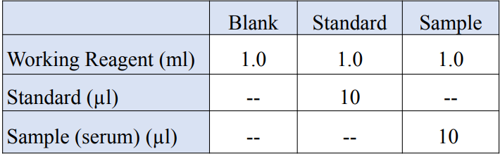

**Calculation**

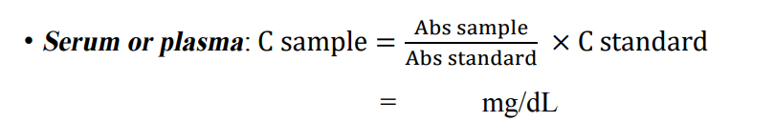

**• C sample = concentration of sample (unknown)**

**• C st. = concentration of standard (10 mg/dL)**

**• Abs sample = absorbance of the sample**

**• Abs st. = absorbance of standard**

**Reference values**

