الملحق array

The memory location of an element in a one-dimensional array is calculated using the base address, the size of each element, and the index (subscript) of the element. In most programming languages, this follows a zero-based indexing system, meaning the first element is at index 0.
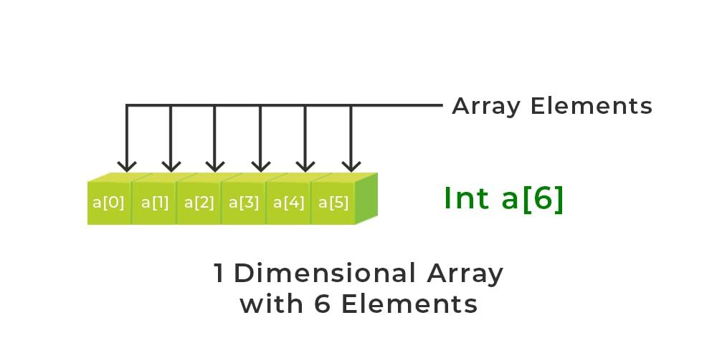
The formula to determine the address of an element A[i] is:
Address of A [i] =𝐵+𝑊×(i−𝐿𝐵)
Where:
- B (Base Address): The memory address of the first element (e.g., A[0]).
- W (Weight): The storage size of one element in bytes (e.g., 2 bytes for a 16-bit integer, 4 bytes for a 32-bit integer).
- i: The index of the element whose address is to be found.
- LB (Lower Bound): The starting index of the array (usually 0).
Example 1:
Assume an integer array X starts at address 500, and each integer takes 1 unit of memory (for simplicity). To find the address of X[4]:

- Base Address (B): 500 Index (i): 4 Lower Bound (LB): 0 Size (W): 1
Calculation: Address of A [I] =𝐵+𝑊×(𝑖−𝐿𝐵)
Location=500+1×(4−0)=504
Note: If the index starts at 1, the formula adjusts to
500+1×(4−1)=503
500+1×(4−1)=503

Calculating the address of any element In the 1-D array:
To find the address of an element in an array the following formula is used-
Address of A[Index] = B + W * (Index - LB)
Where:
- Index = The index of the element whose address is to be found (not the value of the element).
- B = Base address of the array.
- W = Storage size of one element in bytes.
- LB = Lower bound of the index (if not specified, assume zero).

Example: 2
Given the base address of an array A[1300 ............ 1900] as 1020 and the size of each element is 2 bytes in the memory, find the address of A[1700].
Solution:
Given:
- Base address (B) = 1020
- Lower bound (LB) = 1300
- Size of each element (W) = 2 bytes
- Index of element (not value) = 1700

Formula used:
Address of A[Index] = B + W * (Index - LB)
Address of A[1700] = 1020 + 2 * (1700 - 1300)
= 1020 + 2 * (400)
= 1020 + 800
Address of A[1700] = 1820

Example 3
An integer array A starts at memory address 1000, and each integer requires 4 bytes. Find the address of A[5] (assuming 0-based indexing).
- Base Address (B): 1000
- Size (W): 4
- Index (I): 5
- Lower Bound (LB): 0
Formula: Address of A [I] =𝐵+𝑊×(𝑖−𝐿𝐵)
1000+4×(5−0)

1000+4×5=1000+20
Result: 1020

The location law for a one-dimensional (1D) array determines the memory address of a specific element based on the array's base address, element size, and the index.
Formula:
AddressofA[𝑖]=𝐵+𝑊×(𝑖−𝐿𝐵)
- B = Base Address (address of the first element).
- W = Storage Size of one element (in bytes).
- i = Subscript (index) of the element to find.
- LB = Lower Bound/Lower Limit of the array (assumed to be 0 if not specified).
Example 4
Assume an array A starts at memory address 1020, with each element occupying 2 bytes (W). If the array uses 0-based indexing (LB=0), find the address of the element at index 5 ([5])
- B = 1020 W = 2 i = 5 LB = 0
Calculation:
AddressofA[5]=1020+2×(5−0)
AddressofA[5]=1020+2×5
Address of A[5]=1020+10 Address of A[5]=1030
The location of [5] is 1030.

Non-Zero Lower Bound Example
If an array is defined as A[100...200] with a base address of 1000 and element size of 4 bytes, find the address of 𝐴[150]
.
- B = 1000 W = 4 i = 150 LB = 100
Calculation:
Address=1000+4×(150−100)
Address=1000+4×50
Address=1000+200
Address=𝟏𝟐𝟎𝟎
The location of [150] is 1200.

Location (x[i]) = Bass Adress + (i-1)

EX: Let int x[n] an array, compute the location of element x [4] when the baseaddress is 500.

Sol: I=4

Location (x [4]) =500+ (4-1) = 500+3=503.

Solve the following array MCQ questions

Question 1
An array A[10] is stored starting at base address = 500, and each element occupies 4 bytes. What is the address of A[7] if the index starts at 0?
A) 520
B) 528
C) 524
D) 532
Correct Answer: B
Explanation: Address = 500 + (7 × 4) = 528

Question 2
An array B[1..10] is stored starting at base address = 1000 and each element occupies 2 bytes. What is the address of B[6]?
A) 1010
B) 1012
C) 1008
D) 1014
Correct Answer: A
Explanation:
Address = Base + (i − 1) × Size
= 1000 + (6 − 1) × 2
= 1000 + 10 = 1010

Question 3
An array C[0..9] is stored starting at address 4000, and each element occupies 8 bytes. What is the address of C[5]?
A) 4040
B) 4032
C) 4048
D) 4020
Correct Answer: A
Address = 4000 + (5 × 8)
= 4040

Question 4
An array A[0..9] is stored starting at base address = 1000. Each element occupies 3 bytes. What is the address of A[4]?
A) 1012
B) 1010
C) 1016
D) 1009
Correct Answer: A
Explanation:
Address = Base + (Index × Size)
= 1000 + (4 × 3)
= 1012

Question 5
An array B[1..8] is stored starting at address 500. Each element occupies 4 bytes. What is the address of B[5]?
A) 516
B) 520
C) 512
D) 504
Correct Answer: A
Explanation ( index starts at 1):
Address = Base + (i − 1) × Size
= 500 + (5 − 1) × 4
= 500 + 16
= 516

Question 6
An array A[2..10] is stored starting at base address = 1000. Each element occupies 4 bytes. What is the address of A[6]?
A) 1016
B) 1020
C) 1024
D) 1012
Correct Answer: A
Explanation:
Address = Base + (Index − LowerBound) × Size

Question 7 (Reverse Thinking )
An array C[1..10] is stored in memory.
Address of C[1] = 500
Address of C[5] = 532
What is the size of each element?
A) 4 bytes
B) 6 bytes
C) 8 bytes
D) 10 bytes
Correct Answer: C
Difference = 532 − 500 = 32
Indexes difference = 5 − 1 = 4
Size = 32 / 4 = 8 bytes

Question 8 (Find the Index )
An array C[0..9] is stored starting at address 1000.
Each element occupies 4 bytes.
An element is stored at address 1032.
What is its index?
A) 6
B) 7
C) 8
D) 9
Correct Answer: C
Formula:
Index = (Address − Base) / Size
= (1032 − 1000) / 4
= 32 / 4
= 8

Used when the question is about a one-dimensional array.
Formula
Address(A[i])=Base+(i−L)
Where:
- Base = address of the first element
- i = index of the element
- L = lower bound (starting index)
- Size = size of each element in bytes
Example 9
Array A[0..9]
Base = 1000
Size = 4 bytes
Find A[3]
1000+(3−0)×4=
10121000 + (3-0)\times4 =
10121000+(3−0)×4=1012
Answer = 1012

Instead of using the formula directly, just calculate the distance from the first element.
Steps
- Find how many elements away the index is.
- Multiply by the element size.
- Add to the base address.

Example 10
Array A[0..9]
Base = 1000
Size = 4 bytes
Find A[6]
Step 1
Distance = 6 elements
Step 2
6 × 4 = 24
Step 3
1000 + 24 = 1024
Answer = 1024

Example 11
Find A[3] in A[-2..5]
Distance =
3 − (−2) = 5
Then continue normally.

Question 12 (Find the Index)
An array A[0..9] is stored starting at address = 1000.
Each element occupies 4 bytes.
An element is stored at address = 1028.
What is the index of the element?
A) 5
B) 6
C) 7
D) 8
Correct Answer: C
Second Trick
Distance in memory =
1028 − 1000 = 28
Index =
28 ÷ 4 = 7

The Golden Rule
Address difference ÷ element size = index
Array A[-2..5], base address = 1000, size = 2 bytes.
Find the address of A[3].
A) 1010
B) 1008
C) 1012
D) 1014
Answer: A
Trick: Distance = 3 − (−2) = 5 → 5 × 2 = 10 → 1000 + 10 = 1010

Question 13 – 1D Reverse Size
Array B[0..10], base = 500. Address of B[4] = 516.
Find element size.
A) 3 bytes
B) 4 bytes
C) 5 bytes
D) 6 bytes
Answer: B
Trick: Difference = 516 − 500 = 16 → 16 ÷ 4 = 4 bytes

1D Array Questions (1–10)
- A[0..9], base = 1000, size = 4 bytes. Find A[5].
Answer: 1000 + 5×4 = 1020
- B[1..10], base = 2000, size = 2 bytes. Find B[3].
Answer: 2000 + (3−1)×2 = 2004
- C[-2..5], base = 500, size = 3 bytes. Find C[0].
Answer: 500 + (0−(−2))×3 = 500 + 6 = 506
- D[0..9], base = 400, address of D[4] = 424. Find size.
Answer: (424−400)/4 = 6 bytes
- E[1..8], base = 600, address of E[5] = 628. Find size.
Answer: (628−600)/(5−1) = 28/4 = 7 bytes
- F[0..9], base = 1000, size = 8 bytes. Find index for address = 1040.
Answer: (1040−1000)/8 = 5
- G[-3..6], base = 200, size = 2 bytes. Find G[1].
Answer: 200 + (1−(−3))×2 = 200 + 8 = 208
- H[0..5], base = 500, size = 4 bytes. Find H[0].
Answer: 500 + (0−0)×4 = 500
- I[2..7], base = 1000, size = 6 bytes. Find I[4].
Answer: 1000 + (4−2)×6 = 1000 + 12 = 1012
- J[-1..9], base = 800, size = 5 bytes. Find index for address = 835.
Answer: (835−800)/5 + (lower bound) = 7+(-1)=6

MCQ Questions

Question 1
What is the formula used to calculate the address of an element in a one-dimensional array?
A) Address = Base + (Index × Size)
B) Address = Base + (Index + Size)
C) Address = Base × (Index + Size)
D) Address = Index + Size
Correct Answer: A

Question 2
If the base address = 1000 and the size of each element = 4 bytes, what is the address of A[5]?
A) 1004
B) 1020
C) 1005
D) 1040
Correct Answer: B
Explanation:
Address = 1000 + (5 × 4) = 1020

Question 3
If the array index starts from 0, what is the formula for the address of A[i]?
A) Base + (i × size)
B) Base + (i + size)
C) Base × (i × size)
D) Base + size
Correct Answer: A

Question 4
If the array index starts from 1, what is the correct formula to calculate the address?
A) Base + (i × size)
B) Base + (i − 1) × size
C) Base × (i − 1)
D) Base + size
Correct Answer: B

Question 5
If Base = 2000 and size of each element = 2 bytes, what is the address of A[3] (index starts at 0)?
A) 2002
B) 2004
C) 2006
D) 2010
Correct Answer: C
Explanation:
Address = 2000 + (3 × 2) = 2006

