Diode Equivalent Models

Shockley’s equation gives the exponential relationship between current and voltage, but every time while using diodes in a circuit, we do not need to apply the exponential formula to find the values of voltage or current. We can approximate the characteristic of diode by replacing the diode in the circuit with its equivalent circuit.

An equivalent circuit is a combination of elements that best represents the actual terminal characteristics of the device. It simply means the diode in the circuit can be replaced by other elements without severely affecting the behavior of circuit.

The diode can be modeled in three different ways depending on the accuracy required. Three models with increasing accuracy are listed below:

- Ideal Diode Model.
- Simplified Model (approximate model).
- Piece-Wise Linear Model (complete model).

1. Ideal Diode Model
Figure indicates that the voltage drop across the diode is zero for any value of diode current. The ideal diode does not allow any current to flow in reverse biased condition. The current flowing through the diode is zero for any value of reverse biased voltage. Taking this into consideration, the ideal diode can be modeled as open or closed switch depending on the bias voltage.

  - Ideal diode allows the flow of forward current for any value of forward bias voltage. Hence, Ideal diode can be modeled as closed switch under forward bias condition. This is shown in the figure.

  - Ideal diode allows zero current to flow under reverse biased condition. Hence it can be modeled as open switch. This is indicated in the figure.
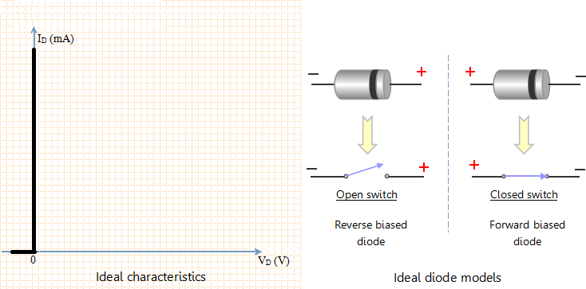

Simplified Model

The equivalent model in this case consists of a threshold voltage {as battery} and an ideal diode. Consider the horizontal line from (0 to 0.7 V) in the curve. The horizontal line indicates that the current flowing through diode is zero for voltages between 0 and 0.7 V. To model this behavior, we put a threshold voltage {as battery} of 0.7 V in the equivalent diode model. This does not mean that diodes are a source of voltage. When you measure the voltage across an isolated diode, the instrument will show zero value. The battery simply indicates that it opposes the flow of current in forward direction until 0.7 V. As the voltage becomes larger than 0.7 V, the current starts flowing in forward direction.
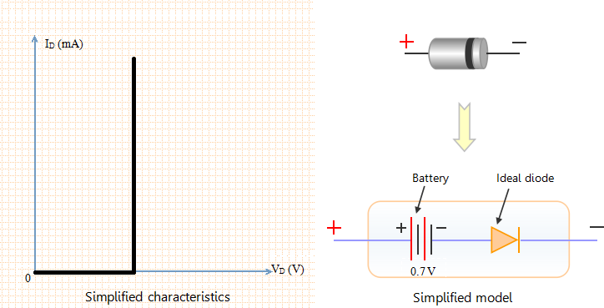

Piece-Wise Linear Model
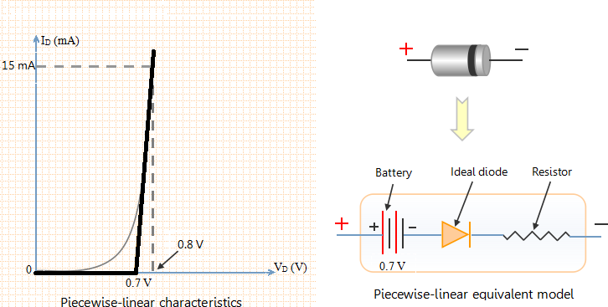
The piece-wise linear model, as the name suggests, is a model in which the characteristics of diode is approximated by “piece-wise linear” line segments. Now consider the straight line in the piece-wise linear characteristics. This straight line indicates constant slope. Slope in the V-I graph indicates resistance. So we add a resistor in the diode model. The value of resistance can be found from the graph. We can see from the graph that the diode current changes from 0 to 15 mA for a voltage change from 0.7 to 0.8 V. Thus the average value of resistance is (0.8 V-0.7 V)/(15 mA - 0 mA) = 6.67 Ω. Thus the value of resistance in the equivalent model is approximately 6.67 Ω. The figure given below shows piece-wise linear characteristics of diode.
In the graph shown on left, the actual characteristics of diode is piece-wise linear characteristics. It is clear that the piece-wise linear characteristics represent the characteristics of diode. However it provides a good actual characteristic of the diode. Piece- wise linear characteristics can be obtained by replacing the diode in the circuit with a resistor, a battery and an ideal diode. This is shown in the right side of the above figure.

