Reverse Bias

In the reverse bias condition, the positive terminal of the battery is connected to the N-type material and the negative terminal of the battery is connected to the P-type material. Hence, the electric field due to both the voltage and depletion layer is in the same direction. This makes the electric field stronger than before.
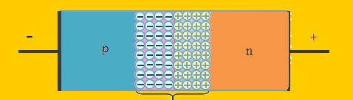
Depletion layer in Reverse Biased condition

The electrons from the N-type semiconductor are attracted towards the positive terminal and the holes from the P-type semiconductor are attracted to the negative terminal. This leads to the reduction of the number of electrons in N-type and holes in P-type. In addition, positive ions are created in the N-type region and negative ions are created in the P-type region. Therefore, the depletion layer width is increased due to the increasing number of positive and negative ions.
Due to this strong electric field, electrons and holes want more energy to cross the junction so they cannot diffuse to the opposite region. Hence, there is no current flow due to the lack of movement of electrons and holes.

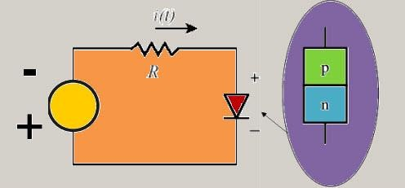

Circuit diagram for Reverse bias

V-I Characteristics

Due to thermal energy in crystal minority carriers are produced. Minority carriers mean a hole in N-type material and electrons in P-type material. These minority carriers are the electrons and holes pushed towards P-N junction by the negative terminal and positive terminal, respectively. Due to the movement of minority carriers, a very little current flow, this is in nano Ampere range (for silicon). This current is called as reverse saturation current. Saturation means, after reaching its maximum value, a steady state is reached where in the current value remains same with increasing voltage.
The magnitude of reverse current is of the order of nano-amperes for silicon devices. When the reverse voltage is increased beyond the limit, then the reverse current increases drastically. This particular voltage that causes the drastic change in reverse current is called reverse breakdown voltage.

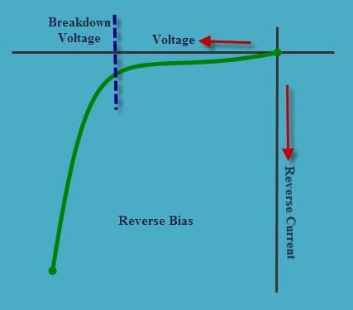

V-I Characteristics Graph for Reverse Bias

V-I Characteristics of P-N junction Diode

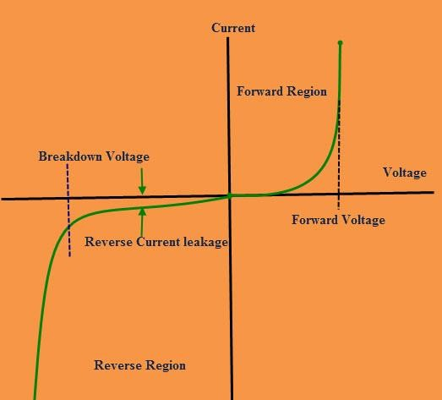
V-I Characteristics of P-N junction Diode

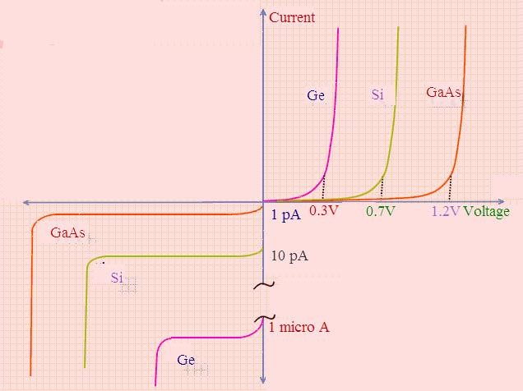
The graph will be changed for different semiconductor materials used in the construction of a P-N junction diode. The below diagram depicts the changes.

Comparison with Silicon, Germanium, and Gallium Arsenide

It can be demonstrated through the use of solid-state physics that the general characteristics of a semiconductor diode can be defined by the following equation, referred to as Shockley’s equation, for the forward- and reverse-bias regions:

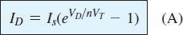

where Is is the reverse saturation current
VD is the applied forward-bias voltage across the diode
n is an ideality factor, which is a function of the operating conditions and physical construction; it has a range between 1 and 2 depending on a wide variety of factors ( n =1 will be assumed throughout this text unless otherwise noted).

The voltage VT in Eq. (1.1) is called the thermal voltage and is determined by
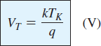
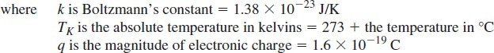

Example 1:
