**Diode Applications**

**LOAD-LINE ANASYSIS OF DIODE CIRCUITS**

The circuit of Fig. below is the simplest of diode configurations. It will be used to describe the analysis of a diode circuit using its actual characteristics. In the next section we will replace the characteristics by an approximate model for the diode and compare solutions. Solving the circuit of Fig. is all about finding the current and voltage levels that will satisfy both the characteristics of the diode and the chosen network parameters at the same time.

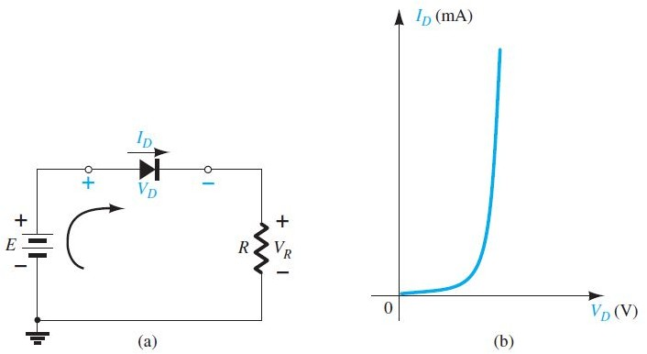

**FIG.**

Series diode configuration: (a) circuit; (b) characteristics*.*

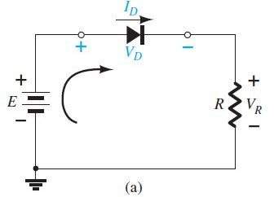**LOAD-LINE ANALYSIS OF DIODE CIRCUITS**

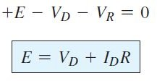By applying KVL, we get

**(2.1)**

But two unknowns, we need one more equation relating *iD* and *vD* to solve the problem.

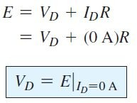

If we *set V D* = 0 V in Eq.(2.1) and solve for *I D* , we have the magnitude of *I D on* the vertical axis. Therefore, with *V D* = 0 V, becomes

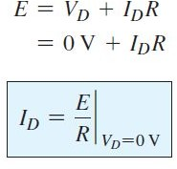**(2.2)**

as shown in Fig. 2.2 . If we *set I D* = 0 A in Eq. (2.1) and solve for *V D* , we have the magnitude of *V D on* the horizontal axis. Therefore, with *I D* = 0 A, Eq. (2.1) becomes

**(2.3)**

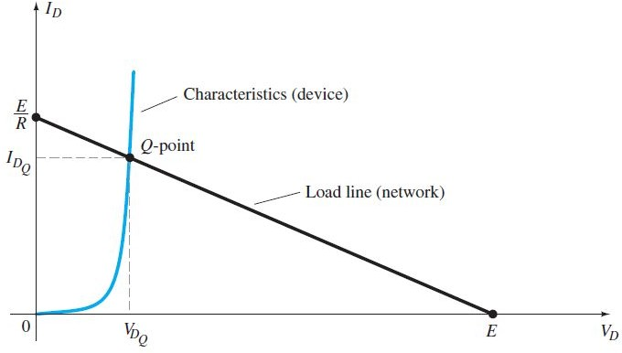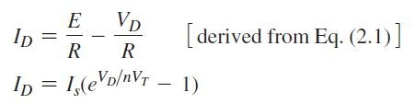

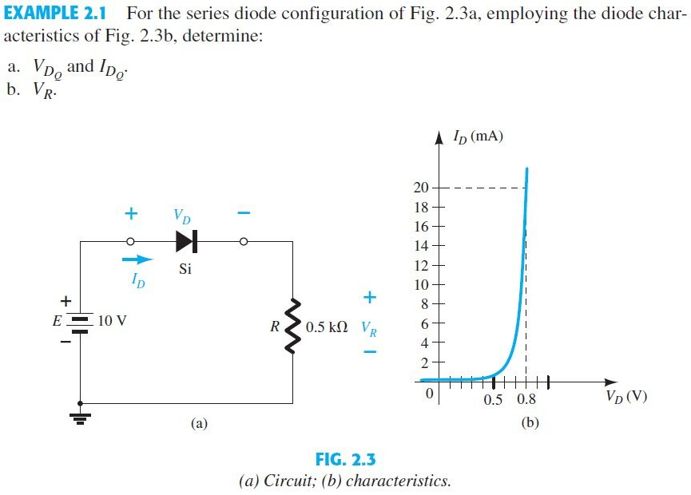

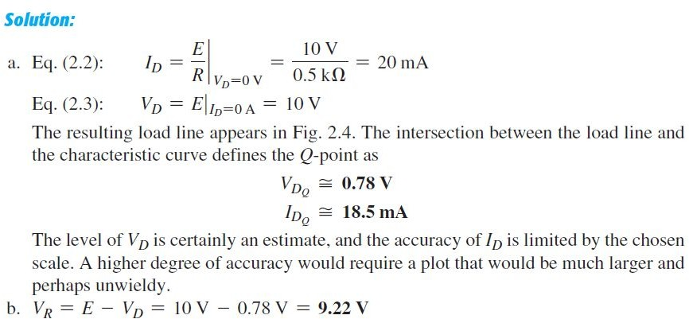

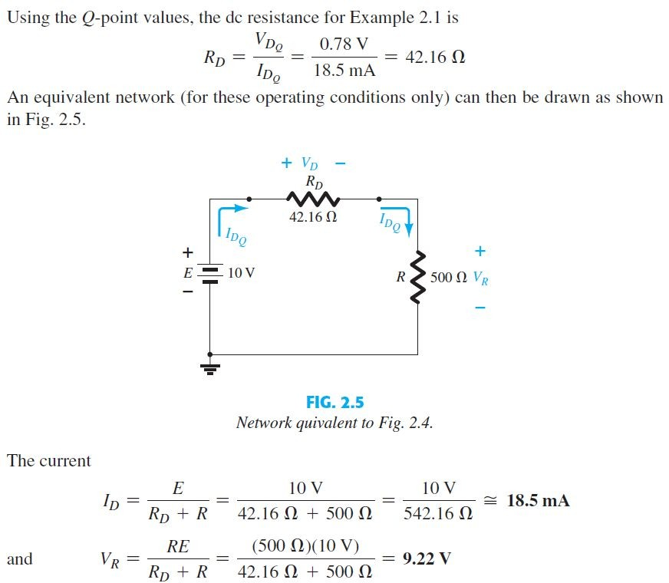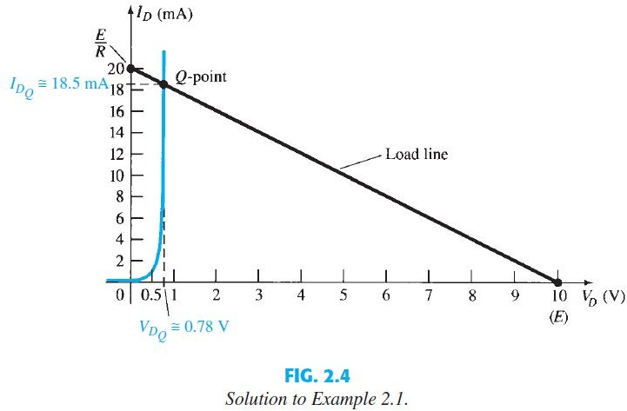

 **EXAMPLE.2.2** For the series diode configuration of Fig. determine *V D* , *V R* , and *I D* .



**Solution:** Since the applied voltage establishes a current in the clockwise direction to match the arrow of the symbol and the diode is in the “on” state



**EXAMPLE**;2.3 Repeat Example above with the diode reversed.

**Solution:** the diode equivalent is the open circuit, where I D = **0 A** due to the open circuit. Since VR = IR R, we have VR = (0)R = **0 V**. Applying Kirchhoff’s voltage law around the closed loop yields

**EXAMPLE:2.4**Determine Vo and ID for the series circuit of Fig. below.

Solution:





**EXAMPLE :**2.5 Determine Vo, *I*1, *ID*1, and *ID*2 for the parallel diode

configuration of the Figure.

Solution:





