P-N Junction Diode Theory and Working

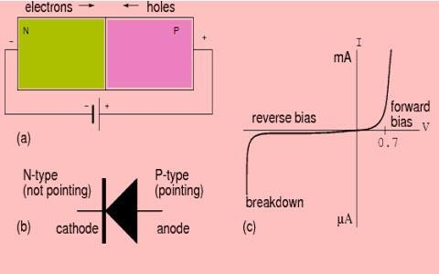
A P-N Junction Diode is formed by doping one side of a piece of silicon with a P- type and the other side with an N-type can be used instead of Silicon. The P-N junction diode is a two-terminal device. This is the basic construction of the P-N junction diode. The diode is one of the simplest semiconductor devices as it allows current to flow in only one direction. The diode does not behave linearly with respect to the applied voltage, and it has an exponential V-I relationship.

There are two operating regions: P-type and N-type. And based on the applied voltage, there are three possible “biasing” conditions for the P-N Junction Diode, which are as follows:

Zero Bias – No external voltage is applied to the PN junction diode.
Forward Bias– The voltage potential is connected positively to the P-type terminal and negatively to the N-type terminal of the Diode. Reverse Bias– The voltage potential is connected negatively to the P-type terminal and positively to the N-type terminal of the Diode.

Zero Biased Condition

In this case, no external voltage is applied to the P-N junction diode; and therefore, the electrons diffuse to the P-side and simultaneously holes diffuse towards the N- side through the junction, and then combine with each other. Due to this an electric field is generated by these charge carriers. The electric field opposes further diffusion of charged carriers so that there is no movement in the middle region. This region is known as depletion width or space charge.
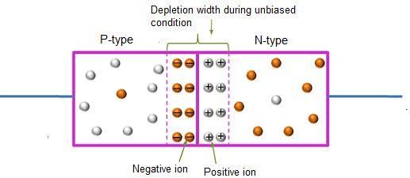
Unbiased Condition

Forward Bias

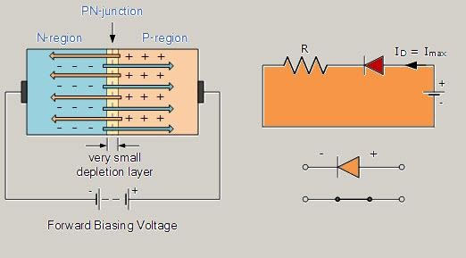
In the forward bias condition, the negative terminal of the battery is connected to the N-type material and the positive terminal of the battery is connected to the P-Type material. Electrons from the N-region cross the junction and enter the P-region. Due to the attractive force that is generated in the P-region the electrons are attracted and move towards the positive terminal. Simultaneously the holes are attracted to the negative terminal of the battery. By the movement of electrons and holes current flows. In this condition, the width of the depletion region decreases due to the reduction in the number of positive and negative ions.

Forward Bias Condition

V-I Characteristics

By supplying positive voltage, the electrons get enough energy to overcome the potential barrier (depletion layer) and cross the junction and the same thing happens with the holes as well. The amount of energy required by the electrons and holes for crossing the junction is equal to the barrier potential 0.3 V for Ge and 0.7 V for Si, 1.2V for GaAs. This is also known as Voltage drop. The voltage drop across the diode occurs due to internal resistance. This can be observed in the below graph.

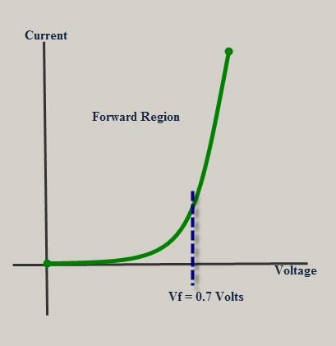
Forward bias V-I Characteristic

