كلية المأمون
قسم التخدير

المرحلة الثانية
Medical Terminology

Lec: 2

MSc: Sarmad.Mohammed

The prefix

Prefixes are letters which we add to the beginning of a word to make a new word with a different meaning. Prefixes can, for example, create a new word opposite in meaning to the word the prefix is attached to

The prefix can be added in front of the term to modify the word root by giving additional information about the location of an organ, the number of parts, or time involved. as well as in medical and scientific terminology. When a medical word (ventilation) contains a prefix (hyper), the meaning of the word is altered (hyperventilation). Not all medical terms have prefixes. By learning to recognize a few of the more commonly used medical prefixes, you can figure out the meanings of terms that may not be immediately familiar to you.

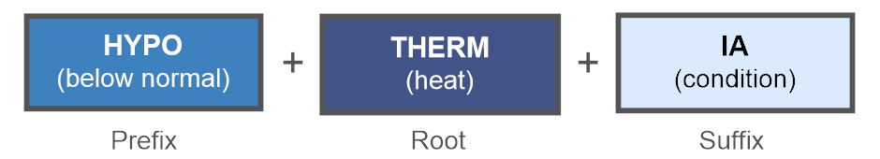

Table 1-3 Common Prefixes of Medical Terms and meaning
Prefixes | Meaning
An- | Without
Ante- | Before
Anti- | Against
Auto- | self
Brady- | Slow
Contra- | Against
Dys- | Painful
Endo- | Within , inner
Epi- | upon, over
eu- | normal, good
Ex- | external, outward
Exo- | outward
Extra- | outside of
hetero- | different
homo- | same
hydro- | water
hyper- | over, above
hypo- | under, below
post- | After
pre- | before, in front of
Pseudo- | False
Retro- | backward, behind
sub- | below, under
Supra- | Above
Tachy- | Fast
Trans- | through, across
un | Not

Categories of Prefixes
Dividing prefixes into functional categories, just as we did with suffixes, makes them easier to learn.
There are four logical divisions:
- prefixes of time or speed
- prefixes of direction
- prefixes of position
- prefixes of size or number

Table 3-1 lists prefixes that indicate a time or speed.

 | Refers to | Prefix
 | Before | ante-, pre-
 | abnormally slow rate of speed | brady-
 | New | neo-
 | After | post-
 | rapid, abnormally high rate of speed | tachy-

Table 3-2 lists prefixes that indicate direction
 | Refers to | Prefix
 | away from, outside of, beyond | ab-
 | toward, near to | ad-
 | With | con-, sym-, syn
 | Against | Contra-
 | across, through | dia-

Table 3-3 lists prefixes that indicate position
 | Outside | ec-
 | Outside | ecto-
 | Inside | en-
 | Within | endo-
 | upon, | epi-
 | Outside | ex-
 | Outside | exo-
 | Beyond | extra-
 | above, beyond normal | hyper-
 | below, below normal | hypo-
 | inside or below | infra-
 | Between | inter-
 | Inside | intra-
 | Middle | meso-
 | alongside, like | para-
 | backward, behind | retro-

Table 3-4 lists prefixes that indicate size or number.
 | Two | bi-
 | semi- half | hemi-
 | Big | Macro
 | Small | micro-
 | One | mono-
 | oligo- a few | olig-,
 | Four | quadri-
 | Three | tri-
 | One | uni-

