Experiment 2
Series Connection of Resistors

Objectives:
To study the characteristics of series connection of resistors
Theory:
When we connect resistors in series, the total equivalent resistor of the connection will equal to the summation of the values of the resistors. That is:
R_{T} = R₁ + R₂ + … + R_{n}
The total current will be equal to the current of each resistor in series connection. That is:
I_{T} = I₁ = I₂ = … = I_{n}
The total voltage will be equal to the summation of voltages developed across each resistor. Which means that the total voltage will be divided between the resistors. That is:
V_{T} = V₁ + V₂ + … + V_{n}

The resistor with the highest value will develop a higher voltage than the resistor with the lowest value. According to Ohm's law:
V = I∙R

Procedure:
1- Connect the circuit as shown in figure below and measure the total resistance:
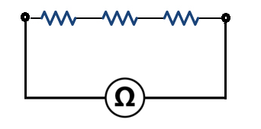
1KΩ 1KΩ 2KΩ

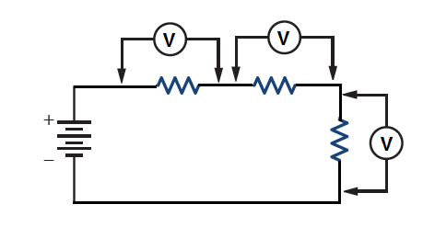
2- Connect the circuit as shown in figure below and measure the voltage across each resistor:

1KΩ 1KΩ
V_{in}=10V 2KΩ

3- Connect the circuit as shown in figure below and measure the total current of the circuit and the current through 2KΩ resistor:

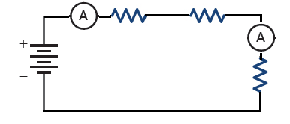
1KΩ 1KΩ

V_{in}=10V
2KΩ

Discussion:
1- From the measured values in the procedure, calculate the consumed power in each resister.
2- For the circuit in procedure, calculate theoretically the current and voltage for each resistor.
3- For the circuit in procedure, if we replace the 2KΩ resistor with 1KΩ, how does the values of current and voltage across the resistors affected.

